Exam Answer Key
- The accessory glands of the mammalian digestive system are: (2 marks)
- salivary glands
- the pancreas
- the liver
- Stomach
- A, b, c are correct
- All of the above
- What the terminal acceptor of electrons in the ETC? (2 marks)
- Water
- Hydrogen peroxide
- Carbon dioxide
- Molecular oxygen
- An amphibian such as a frog ventilates its lungs by: (2 marks)
- Negative pressure breathing
- Tracheal system
- Positive Pressure Breathing
- One direction air movement
- Cholesterol is: (2 marks)
- Fat
- Steroids
- A digestive organ
- A hormone
- b & d are correct
- a, b, & d are correct
- The Peroxisome is: (2 marks)
- An organelle with various specialized metabolic functions; produces hydrogen peroxide as a by-product, then converts it to water
- An organelle where cellular respiration occurs and most ATP is produced
- An organelle active in synthesis, modification, sorting, and secretion of cell products
- A digestive organelle where macromolecules are hydrolyzed
- Many aquatic animals are: (2 marks)
- Substrate feeders
- Bulk feeders
- Fluid feeders
- Suspension feeders
- In the article “A Burger a Day”, what compound was used to decrease the amount of cholesterol in our foods? (2 marks)
- Sterols
- Enzymes
- Unsaturated fats
- Plant Chloroplast
- Glycolysis occurs in: (2 marks)
- The cytosol
- The lysosome
- The mitochondria
- The matrix
- The stomach is located just below the: (2 marks)
- Diaphragm
- Liver
- Esophagus
- Large intestine
- Which of these are saturated fats: (2 marks)
- Lard
- Butter
- Olive Oil
- Only a & b
- All of the above
- In glycolysis, glucose-6-phosphate enters a series of reactions to eventually get converted to: (2 marks)
- Pyruvate
- G3P
- Alpha-ketogluterate
- Malate
- a & b are correct
- a & d are correct
- The article “Narrative Portrayls of Genes and Human Flourishing” by Aline H. Kalbian focuses on: (2 marks)
- Prenatal genetic testing
- Genes
- Gene discrimination
- GATTACA
- All of the above
- What is located where the stomach opens to the small intestine to help regulate the passage of chyme into the small intestine? (2 marks)
- Epiglottis
- Sphincter
- Villi
- Bile
- Chemiosmosis couples: (2 marks)
- Glycolysis and the proton gradient
- TCA and ATP synthase
- ATP synthase and the proton gradient
- ETC and the proton gradient
- The endoplasmic reticulum is: (2 marks)
- A network of membranous sacs and tubes; active in membrane synthesis and other synthetic and metabolic processes
- A double membrane enclosing the nucleus
- Reinforces cell’s shape, functions in cell movement; components are made of proteins
- A locomotion organelle present in some animal cells
- The terminal portion of the large intestine is: (2 marks)
- Anus
- Sphincter
- Rectum
- Reproduction organs
- The consumption of more calories than the body needs for normal metabolism, causes: (2 marks)
- A higher metabolic rate
- Obesity due to clogged arteries
- A higher pH in the stomach
- All of the above
- Veins: (2 marks)
- Carry blood back to the heart
- Carry blood away from the heart
- Are microscopic blood vessels
- Carry out gas exchange
- In the TCA cycle, FADH2 is released at which of the following stages: (2 marks)
- When oxidizing malate
- When oxidizing Succinic acid
- When reducing malate
- When reducing succinic acid
- Will the future be: (2 marks)
- Ruled by robots
- We will all die in 2012, there is no future
- Ruled by people with super powers
- Everything will be done by a computer, we won’t have to leave our house
- I do not know. We shall find out
- Label any of the 5 missing arteries or veins: (5 marks)

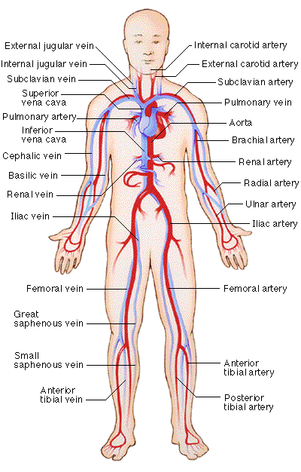
- Describe in detail how a mammal breathes. Provide the full branching pathway. (10 marks)
Mammals employ negative pressure breathing – pulling rather than pushing air into their lungs. Using muscle contraction at actively expand the thoracic cavity, mammals lower air pressure in their lungs below that of the air outside the body. Because gas flows from a region of higher pressure to a region of lower pressure, air rushes through the nostrils and mouth and down the breathing tubes to the alveoli. During exhalation, the muscles controlling the thoracic cavity relax, and the volume of the cavity is reduced. The increased air pressure in the alveoli forces air up the breathing tubes and out of the body. Thus, inhalation is always active and requires work, whereas exhalation is usually passive.
Expanding the thoracic cavity during inhalation involves the animal’s rib muscles and the diaphragm, a sheet of skeletal muscles that forms the bottom wall of the cavity. Contracting the rib muscles expand the rib cage, the front wall of the thoracic cavity, by pulling the ribs upwards and the sternum outward. At the same time, the diaphragm contracts, expanding the thoracic cavity downward.
Within the thoracic cavity, a double membrane surrounds the lungs. The inner layer adheres to the outside of the lungs, and the outer layer adheres to the wall of the thoracic cavity. A thin space filled with the fluid separates the two layers.

- Describe in detail how the circulatory system of a mammal. Provide the full pathway blood takes. (10 marks)
Contraction of the right ventricle pumps blood to the lungs via 2) the pulmonary arteries. As the blood flows through 3) capillary beds in the left and right lungs, it loads oxygen and unloads carbon dioxide. Oxygen-rich blood returns from the lungs via the pulmonary veins to 4) the left atrium of the heart. Next, the oxygen-rich blood flows into 5) the left ventricle, which pumps the oxygen-rich flood out to the body tissues through the systemic circuit. Blood leaves the left ventricle via 6) the aorta, which conveys blood to arteries leading throughout the body. The first branches of the aorta are coronary arteries, which supply blood to the heart. Then branches lead to 7) capillary beds in the head and arms. The aorta then descends into the abdomen, supplying oxygen-rich blood to arteries leading to 8) capillary beds in the abdominal organs and legs. Within the capillaries, there is net diffusion. Oxygen-poor blood from the head, neck, and forelimbs is channeled into a large vein, 9) the superior vena cava. Another large vein, 10) the inferior vena cava, drains blood from the trunk and hind limbs. The two venae cavae empty their blood into 11) the right atrium, from which the oxygen-poor blood flows into the right ventricle.

- What is the genotypic ratio of the progeny produced from this mating?
Parental cross: female aaBb crossed with a male AABb (2 marks)
- You were thrilled to have a new baby sister, but excitement turned to
anxiety when she began to have digestive problems with persistent
vomiting. Doctors quickly learned that she had an autosomal
recessive disorder called galactosemia. Your sister lacked the enzyme
that breaks down the milk sugar galatose, so her pediatrician put her
on a special diet free of lactose and galactose. In a short time, your
sister was fine. (3 marks)
a. Neither of your parents is affected with galactosemia. If your
sister's genotype is gl/gl, what are your parents' genotypes?
b. You are not affected with galactosemia. What is your genotype or
possible genotypes?
c. Will your sister automatically pass on this disease to her children?
Why or why not?

