Exam
- The accessory glands of the mammalian digestive system are: (2 marks)
- salivary glands
- the pancreas
- the liver
- Stomach
- A, b, c are correct
- All of the above
- What the terminal acceptor of electrons in the ETC? (2 marks)
- Water
- Hydrogen peroxide
- Carbon dioxide
- Molecular oxygen
- An amphibian such as a frog ventilates its lungs by: (2 marks)
- Negative pressure breathing
- Tracheal system
- Positive Pressure Breathing
- One direction air movement
- Cholesterol is: (2 marks)
- Fat
- Steroids
- A digestive organ
- A hormone
- b & d are correct
- a, b, & d are correct
- The Peroxisome is: (2 marks)
- An organelle with various specialized metabolic functions; produces hydrogen peroxide as a by-product, then converts it to water
- An organelle where cellular respiration occurs and most ATP is produced
- An organelle active in synthesis, modification, sorting, and secretion of cell products
- A digestive organelle where macromolecules are hydrolyzed
- Many aquatic animals are: (2 marks)
- Substrate feeders
- Bulk feeders
- Fluid feeders
- Suspension feeders
- In the article “A Burger a Day”, what compound was used to decrease the amount of cholesterol in our foods? (2 marks)
- Sterols
- Enzymes
- Unsaturated fats
- Plant Chloroplast
- Glycolysis occurs in: (2 marks)
- The cytosol
- The lysosome
- The mitochondria
- The matrix
- The stomach is located just below the: (2 marks)
- Diaphragm
- Liver
- Esophagus
- Large intestine
- Which of these are saturated fats: (2 marks)
- Lard
- Butter
- Olive Oil
- Only a & b
- All of the above
- In glycolysis, glucose-6-phosphate enters a series of reactions to eventually get converted to: (2 marks)
- Pyruvate
- G3P
- Alpha-ketogluterate
- Malate
- a & b are correct
- a & d are correct
- The article “Narrative Portrayls of Genes and Human Flourishing” by Aline H. Kalbian focuses on: (2 marks)
- Prenatal genetic testing
- Genes
- Gene discrimination
- GATTACA
- All of the above
- What is located where the stomach opens to the small intestine to help regulate the passage of chyme into the small intestine? (2 marks)
- Epiglottis
- Sphincter
- Villi
- Bile
- Chemiosmosis couples: (2 marks)
- Glycolysis and the proton gradient
- TCA and ATP synthase
- ATP synthase and the proton gradient
- ETC and the proton gradient
- The endoplasmic reticulum is: (2 marks)
- A network of membranous sacs and tubes; active in membrane synthesis and other synthetic and metabolic processes
- A double membrane enclosing the nucleus
- Reinforces cell’s shape, functions in cell movement; components are made of proteins
- A locomotion organelle present in some animal cells
- The terminal portion of the large intestine is: (2 marks)
- Anus
- Sphincter
- Rectum
- Reproduction organs
- The consumption of more calories than the body needs for normal metabolism, causes: (2 marks)
- A higher metabolic rate
- Obesity due to clogged arteries
- A higher pH in the stomach
- All of the above
- Veins: (2 marks)
- Carry blood back to the heart
- Carry blood away from the heart
- Are microscopic blood vessels
- Carry out gas exchange
- In the TCA cycle, FADH2 is released at which of the following stages: (2 marks)
- When oxidizing malate
- When oxidizing Succinic acid
- When reducing malate
- When reducing succinic acid
- Will the future be: (2 marks)
- Ruled by robots
- We will all die in 2012, there is no future
- Ruled by people with super powers
- Everything will be done by a computer, we won’t have to leave our house
- I do not know. We shall find out
- Label any of the 5 missing arteries or veins: (5 marks)
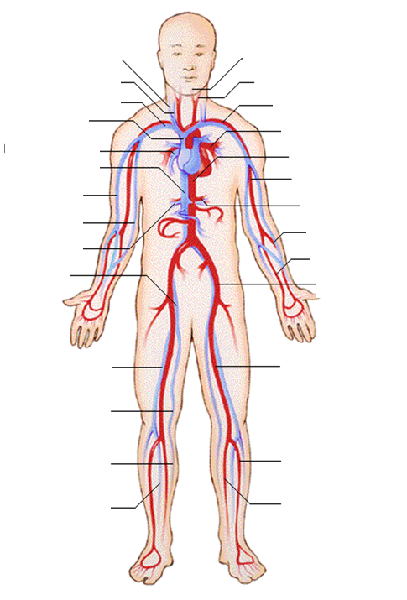

- Describe in detail how a mammal breathes. Provide the full branching pathway. (10 marks)
- Describe in detail how the circulatory system of a mammal. Provide the full pathway blood takes. (10 marks)
- What is the genotypic ratio of the progeny produced from this mating?
Parental cross: female aaBb crossed with a male AABb (2 marks)
- You were thrilled to have a new baby sister, but excitement turned to
anxiety when she began to have digestive problems with persistent
vomiting. Doctors quickly learned that she had an autosomal
recessive disorder called galactosemia. Your sister lacked the enzyme
that breaks down the milk sugar galatose, so her pediatrician put her
on a special diet free of lactose and galactose. In a short time, your
sister was fine. (3 marks)
a. Neither of your parents is affected with galactosemia. If your
sister's genotype is gl/gl, what are your parents' genotypes?
b. You are not affected with galactosemia. What is your genotype or
possible genotypes?
c. Will your sister automatically pass on this disease to her children?
Why or why not?

